Civil Society & Development
DEVS802H2

Course Coordinator: Prof Shauna Mottiar
Room A729, Level 7 Shepstone, Howard College, SOBEDS,UKZN
Tel: 031 260 2940
Email: mottiar@ukzn.ac.za

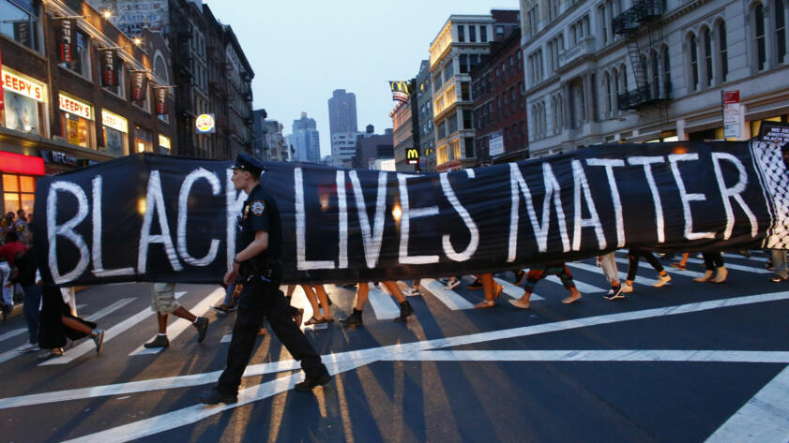

Seminar 1 Civil Society Theories and Interpretations
Seminar 2 NGOs and NGOization
Seminar 3 New Social Movements and Contemporary Struggles
Seminar 4 #BlackLivesMatter
Seminar 5 The Evolution of Civil Society in South Africa: Social Movements and Social Protest
Seminar 6 Democratic Accountability, Participatory Government and Civil Society in South Africa
Seminar 7 Globalization and Global Civil Society: The World Social Forum
Seminar 8 Philanthropy v Charity and Social Justice
Seminar 9 Social Entrepreneurship and Social Transformation

